**Documentation, Superstore Sales PowerBI Dashboard**

*-Team I*

**1. Project Overview**

* **Objective**: Analyse and visualize the Superstore Sales dataset to extract valuable insights on sales performance, regional trends and product segments.
* **Dataset Name**: SuperStore Sales
* **Primary Audience**: Business stakeholders and Sales team who requested the data-driven insights for decision-making.
* **Main questions received from one of the sales team members**:

1. Why are sales significantly higher in certain regions compared to others, and what strategies can we implement to boost sales in lower-performing areas?
2. What are the key factors contributing to the higher sales of specific product categories like Technology, and how can we replicate this success across other categories
3. Can we identify any seasonal trends or peak sales periods, and how can we align our marketing campaigns to capitalize on these high-demand months
4. Who are our top customers, and what loyalty strategies can we implement to retain them and increase their purchase frequency?
5. What shipping methods do our customers prefer, and is there an opportunity to optimize our logistics to improve customer satisfaction and reduce costs

**2. Data and it’s preparation**

* **Contents of the dataset**: The dataset includes following 20 columns:

1. category
2. city
3. country
4. customer ID
5. customer name
6. discount
7. order date
8. order ID
9. product ID
10. product name
11. postal code
12. quantity
13. region
14. sales price
15. segment
16. serial no.
17. ship date
18. ship mode
19. sub-category
20. turnover

* **Data Cleaning Steps**: Performed necessary transformations, such as:
  + Formatting date columns (Order Date, Ship Date) for consistency.
  + Removing duplicate entries and handling missing values, particularly in turnover and Processing Time.
* **Calculated Columns**: Created additional columns, such as:
  1. **Total profit** as (1-discount) * sales price * quantity
  2. **Sales per Item** as sales / quantity
  3. **Processing Time** as Ship Date – Order Date

**3.DAX Queries and Calculations**: Defined critical measures using DAX to capture business metrics as follows:

* + Average_order_value = AVERAGE(SuperStore[Total Profit])
  + Card Color = IF('SuperStore'[Sales Growth Rate %] < 0, 0, 1)
  + Customer Lifetime Value = CALCULATE(SUMX(SuperStore, SuperStore[Sale Price] * SuperStore[Quantity]), ALL(SuperStore[Customer ID]))
  + Sales by Region = SUMX(SuperStore, SuperStore[Sale Price] * SuperStore[Quantity])
  + Sales Growth Rate % =

VAR SelectedYear = SELECTEDVALUE(SuperStore[Order Date].[Year])

VAR StartYear = MIN(SuperStore[Order Date].[Year])

VAR EndYear = MAX(SuperStore[Order Date].[Year])

VAR SalesCurrentYear =

    CALCULATE([Total Sale],

        FILTER(ALL(SuperStore), SuperStore[Order Date].[Year] = SelectedYear)

   )

VAR SalesPreviousYear =

    CALCULATE([Total Sale],

        FILTER(ALL(SuperStore), SuperStore[Order Date].[Year] = SelectedYear - 1)

    )

VAR SalesStartYear =

    CALCULATE([Total Sale],

        FILTER(ALL(SuperStore), SuperStore[Order Date].[Year] = StartYear)

    )

VAR SalesEndYear =

    CALCULATE([Total Sale],

        FILTER(ALL(SuperStore), SuperStore[Order Date].[Year] = EndYear)

    )

RETURN

    IF(

        ISBLANK(SelectedYear),

        // If no year is selected, calculate total increase from 2014 to 2017

        IF(

            SalesStartYear = 0,

            0,

            DIVIDE(SalesEndYear - SalesStartYear, SalesStartYear, 0) * 100

        ),

        // If a year is selected, calculate YoY increase

        IF(

            ISBLANK(SalesPreviousYear),

            0, // For 2014, there is no previous year data, so show 0%

            DIVIDE(SalesCurrentYear - SalesPreviousYear, SalesPreviousYear, 0) * 100

        )

    )

* + Top 10 Customers by Sale = TOPN(10, VALUES(SuperStore[Customer ID]), [Total Sale], DESC)
  + Total Sale = SUMX(SuperStore, SuperStore[Sale Price] * SuperStore[Quantity])

**4. Data Modeling**

* Single-Table Structure: The model relies on a single comprehensive table containing all relevant columns as previously mentioned.
* Simplified Data Model: With all data in one table, no relationships or dimension tables are needed. This setup minimizes data redundancy and simplifies analysis.
* Advantages: The single-table structure allows direct access to all fields without the need for complex joins, which is particularly beneficial when working with relatively straightforward datasets like this one.

**5. Visualizations Used**

**1. Card Visuals:**

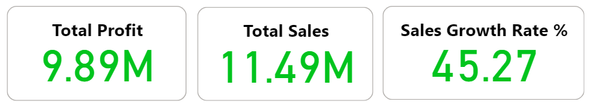

* **Total Profit:**
  + **Description:** This card visual displays the total profit generated by the store, amounting to **9.89M**.
  + **Insight:** A high profit margin indicates a strong performance, suggesting effective cost management and high sales profitability.
* **Total Sales:**
  + **Description:** This card visual represents the total sales revenue, which is **11.49M**.
  + **Insight:** The sales figure indicates a substantial market presence. However, the ratio of profit to sales (approximately 86%) suggests room for improving efficiency and reducing operational costs to increase profit margins.
* **Sales Growth Rate %:**
  + **Description:** This card visual shows the percentage growth rate in sales, which is **45.27%**.
  + **Insight:** A positive growth rate indicates a significant improvement in sales performance compared to previous periods, reflecting successful sales strategies or market expansion.

**2. Sales by Sub-Category (Donut Chart):**

* **Description:** This donut chart displays the percentage contribution of various product sub-categories to total sales. The highest contributions come from **Phones (14.4%)** and **Chairs (14.3%)**, while smaller contributions are from categories like **Paper (3.4%)**.
* **Insight:** The high sales from Phones and Chairs indicate these as top-performing product lines. Lesser contributions from items like Paper suggest these may either be niche products or have lower market demand.

**3. Sales by Segment (Donut Chart):**

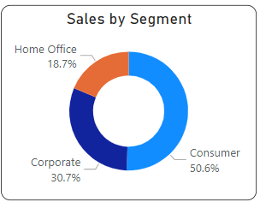

* **Description:** This visual breaks down sales across three segments: **Consumer (50.6%)**, **Corporate (30.7%)**, and **Home Office (18.7%)**.
* **Insight:** The dominance of the Consumer segment highlights its major role in driving sales. Focusing marketing strategies on this segment could potentially yield higher returns, while exploring ways to boost Corporate and Home Office sales could diversify income streams.

**4. Sales by Ship Mode (Donut Chart):**

* **Description:** This donut chart represents sales distribution based on shipping methods, with **Standard Class (59.12%)** being the most utilized, followed by **Second Class (19.99%)**.
* **Insight:** The preference for Standard Class shipping indicates that most customers opt for cost-effective delivery options. However, a higher utilization of expedited shipping methods (e.g., First Class) could signify urgent customer needs or higher-value orders.

**5. Sales by State and Region (Map):**

* **Description:** A geographic heat map visualizing sales distribution across different states in the USA, segmented by regions (Central, East, South, and West).
* **Insight:** The map highlights the **West** region as having the highest sales concentration, while the **South** region shows lower activity. This regional variation could guide tailored sales and marketing strategies, such as focusing on enhancing market penetration in underperforming areas.

**6. Top 10 Customers by Value (Bar Chart):**

* **Description:** This horizontal bar chart lists the top 10 customers based on their purchase value, with **Sean Miller** leading at **146.75K**, followed closely by **Adrian Barton** at **143.86K**.
* **Insight:** The data indicates key high-value customers, whose loyalty could be vital to sustaining high revenue. Customer retention strategies like personalized offers could be beneficial for these top clients.

**7. Total Sales by Month and Year (Area Chart):**

* **Description:** This stacked area chart displays the monthly sales trends across multiple years (2014 to 2017). Each color represents a different year, allowing for year-over-year comparison.
* **Insight:** The chart reveals consistent peak sales in the months of **November and December**, suggesting high seasonal demand, possibly due to holiday shopping. Strategies to maximize sales during these months, like promotions, could be effective.

**8. Top 5 Products Sold (Bar Chart):**

* **Description:** A vertical bar chart showing the top 5 products by sales volume, with the **Canon imageCLASS 2200** copier being the highest-selling product at **253.40K**.
* **Insight:** The high sales of specific products, particularly in office equipment, highlight customer preferences. It may indicate a strong market demand for business and office solutions, guiding future inventory decisions.

**9. Sales by Category (Pie Chart):**

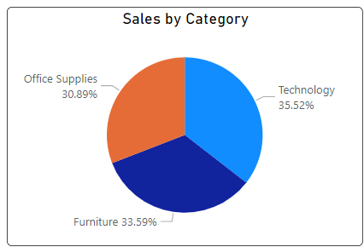

* **Description:** This pie chart visualizes the distribution of sales across three main product categories: Technology (35.52%), Furniture (33.59%), and Office Supplies (30.89%). The slices represent the proportion of total sales contributed by each category.
* **Insight:** The Technology category leads with the highest share, followed closely by Furniture. The comparable contributions of these categories suggest a balanced product portfolio, with no single category dominating significantly. Marketing efforts could focus on further enhancing sales in Technology due to its current lead, while exploring growth opportunities in Office Supplies to even out the distribution.

**10. Sales by Region (Waterfall Chart):**

* **Description:** This waterfall chart breaks down the sales figures across four regions: West (3.6M), East (3.4M), Central (2.5M), and South (2.0M). The cumulative sales amount to a total of 11.5M. Each bar indicates the incremental sales contribution from each region, with green bars showing increases and the final blue bar representing the total sales.
* **Insight:** The West region contributes the highest sales, followed closely by the East, while the South region shows the lowest sales figures. This regional performance analysis highlights potential growth areas, particularly in the South and Central regions. Strategic initiatives like targeted promotions or regional partnerships could help boost sales in these underperforming areas.

**11. Top 10 cities with highest revenue:**

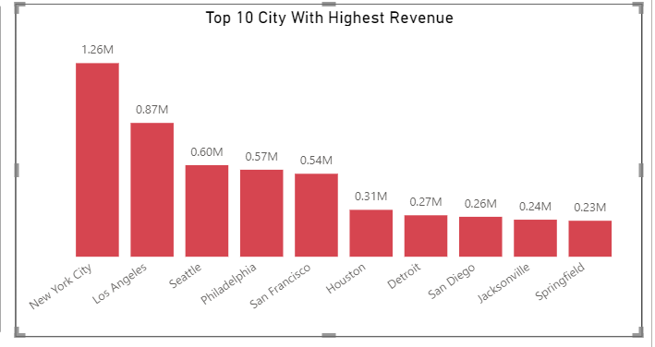

* **Description:** This bar chart displays the top 10 cities with the highest revenue. New York City leads significantly with 1.26M, followed by Los Angeles at 0.87M. Other cities like Seattle, Philadelphia, and San Francisco show moderate revenues, while the bottom cities, such as Springfield, have revenues around 0.23M.
* **Insight:** New York City and Los Angeles are the top revenue-generating cities, contributing significantly more than others. There’s a noticeable revenue drop from San Francisco (0.54M) to Houston (0.31M), indicating disparities among cities. Lower-revenue cities like Springfield and Jacksonville present opportunities for targeted growth strategies**.**

**12. Filters (Top Right Section):**

* **Description:** Filters are available based on region (Central, East, South, West), quarter (Qtr 1 to Qtr 4), and product categories (Furniture, Office Supplies, Technology).
* **Insight:** These filters enable users to perform a granular analysis of sales data, allowing for tailored insights and specific data breakdowns to identify trends in different regions, time periods, or product categories.

**6. Future Enhancements**

*Note: The following enhancements are possible with furthermore detailed and extra data.*

**1. Advanced Analytics and Predictive Modeling**

* **Sales Forecasting**: Integrate time-series forecasting models to predict future sales trends based on historical data. This can help in demand planning and inventory management.
* **Customer Segmentation with Machine Learning**: Use clustering techniques to segment customers based on purchase behavior, geographic location, or other characteristics. This can help in tailoring marketing strategies for different customer groups.

**2. Enhanced Data Integration**

* **Incorporating Additional Datasets**: Include datasets such as marketing spend, competitor pricing, and economic indicators to analyze their influence on sales and profit. This can offer a more comprehensive view of factors impacting sales performance.
* **Cross-Departmental Data**: Merge data from departments like inventory, finance, and marketing to analyze end-to-end operations, from product sourcing to final sale. This integration can help optimize the entire supply chain and improve customer satisfaction.

**3. Real-Time Data Analysis**

* **Real-Time Dashboarding**: Set up a real-time connection to the sales data to analyze live trends and performance. This would provide stakeholders with immediate insights and the ability to respond to fluctuations quickly.
* **Automated Alerts**: Implement alerts for significant events, like low inventory levels or spikes in demand, allowing for timely actions to mitigate potential issues.

**4. Deep Dive into Profitability Analysis**

* **Cost Analysis for Profit Optimization**: Add detailed cost data to analyze how shipping, warehousing, and marketing expenses impact overall profitability. This can assist in identifying cost-saving opportunities.
* **Product Life Cycle Analysis**: Study each product's life cycle to understand when it peaks in popularity and profitability, providing insights for better inventory planning and marketing efforts.

**5. Improved Customer Experience Insights**

* **Customer Feedback Integration**: Add customer feedback or reviews data to evaluate customer satisfaction alongside sales performance, which could aid in enhancing service quality and retention.
* **Predicting Customer Churn**: Identify patterns associated with customer churn to proactively address retention strategies, particularly for high-value customers.

**7. Conclusion**

Based on the analysis, it is evident that there are clear disparities in sales performance across different regions and product categories. The West and East regions are the strongest performers, while the Central and South regions show room for growth. Targeted marketing strategies and localized campaigns could help tap into these underperforming areas, potentially increasing overall sales.

Additionally, the Consumer segment significantly contributes to revenue, emphasizing the need to tailor offerings and promotions to consumer preferences. Analysing the reasons behind the lower sales in the Home Office segment could also present an opportunity for expansion. High sales growth rates and peaks in specific months indicate seasonal trends, suggesting that aligning marketing efforts with these peak periods could further boost sales during high-demand times.

The top product categories, such as Technology and Furniture, highlight strong customer demand for specific office and tech-related products. However, there is potential to enhance sales in Office Supplies through focused promotions or new product offerings. Moreover, insights into shipping preferences reveal a dominant use of Standard Class, pointing to customers' preference for cost-effective options.

Further, by optimizing shipping methods and potentially introducing incentives for faster delivery options, customer satisfaction could be improved. Engaging top customers with loyalty programs and personalized offers can help retain high-value clients and increase their purchase frequency. Overall, leveraging these insights to refine product offerings, enhance regional strategies, and optimize customer experiences will be key to driving further sales growth.